DIVISION-LP-(#): approved on (Date)
 | Equipment Name: | Equipment Owner:
 | Additional Contact(s): | Facility / Building / Room:
 | Additional Contact(s): | Reviewed by: | Approved by:
LOCKOUT/TAGOUT (LOTO) PROCEDURE

LOTO ESTABLISHED _____________________________________  signature / date / time | LOTO CLEARED _________________________________________  signature / date / time

1. SCOPE OF WORK

2. ENERGY ISOLATION CHECKLIST
Electrical
# | Equipment Descriptor | Isolation Point | Isolation Type | Voltage-Type | AF Energy / Boundary | AF PPE | Isolation Position | Established (Initials) | Cleared (Initials)
Non-Electrical
# | Equipment Descriptor | Isolation Point | Isolation Type | Energy Source | Pressure / Thermal / Chemical | PPE | Isolation Position | Established (Initials) | Cleared (Initials)

Energy Dissipation Devices
# | Equipment Descriptor | Dissipation Point | Stored Energy Type | Magnitude | PPE | Device | Established (Initials) | Cleared (Initials)

4. LOTO SEQUENCE (Select 4a, 4b or 4c as applicable)
4a.
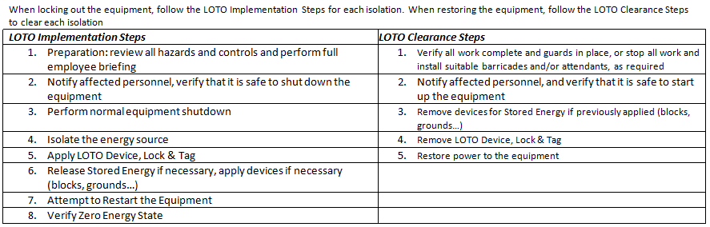
4b:
This LOTO Procedure requires the following LOTO Sequence:

4c:
This LOTO Procedure requires a specific sequence. Follow filedocument.pdf, attached.

5. SIGNATURES
LOTO Authorized Person:
"I agree that the scope of work described in Section 1 falls within the LOTO Safe Zone established by the electrical electrical electrical electrical isolations in Section 2. I have witnessed the implementation of the LOTO according to this permit and that zero energy state was properly verified. By signing here I confirm that the LOTO has been fully established. "

____________________________________________________ ______________
Print Name Signature Date

Qualified personnel establishing the LOTO:
"I have implemented the LOTO according to this LOTO PROCEDURE and I have properly verified zero energy state."
____________________________________________________ ______________
Print Name Signature Date

____________________________________________________ ______________
Print Name Signature Date

____________________________________________________ ______________
Print Name Signature Date
6. Pictures (optional)

